

TEORÍA DE AUTÓMATAS Y LENGUAJES FORMALES
ALEJANDRO SERRANO FERNÁNDEZ
LAB SESSION 4

STATEMENT

A metallurgical company needs your help! There has been an incident and the database files have been mixed up.
They need the steel's sheet ASAP! And they know you have the necessary capacities for it!
The company has given you a comma separated values file with all the data mixed in it, they say the data they need have the following structure:
Element1,Element2,Tolerance
An explanation of every field is detailed next:
1. Element 1: is a real number in the range between 0 and 2 both included.
2. Element 2: is a real number in the range between -1 and 2, both included.
3. Tolerance: is an integer number between 1 and 4.

The company needs you to perform the following task:
Task 1: Design a Regular Expression (as defined in theory lectures) to check the entries of their databases, in order to discover the right ones. Define the alphabet of the language represented by the RE.

E1 = 0+1;
E2 = 2
E3 = -1 + 2
E4 = 1 + 2 + 3 + 4 (Tolerance)
E5 = 1 + 2 + 3 + 4 + 5 + 6 + 7 + 8 + 9
E6 = 0 + 1 + -0

ELEMENT 1 = (E1, E5⁺) + (E2)
ELEMENT 2 = (E6,E5⁺) + (E3)
TOLERANCE = E4

RESULTING REGULAR EXPRESION:
(((E1, E5⁺) + (E2)) , ((E6,E5⁺) + (E3)) , E4)

Task 2: Convert the obtained RE to an ℇ-NFA following the Thompson construction method.

FIRST ELEMENT ε-NFA:
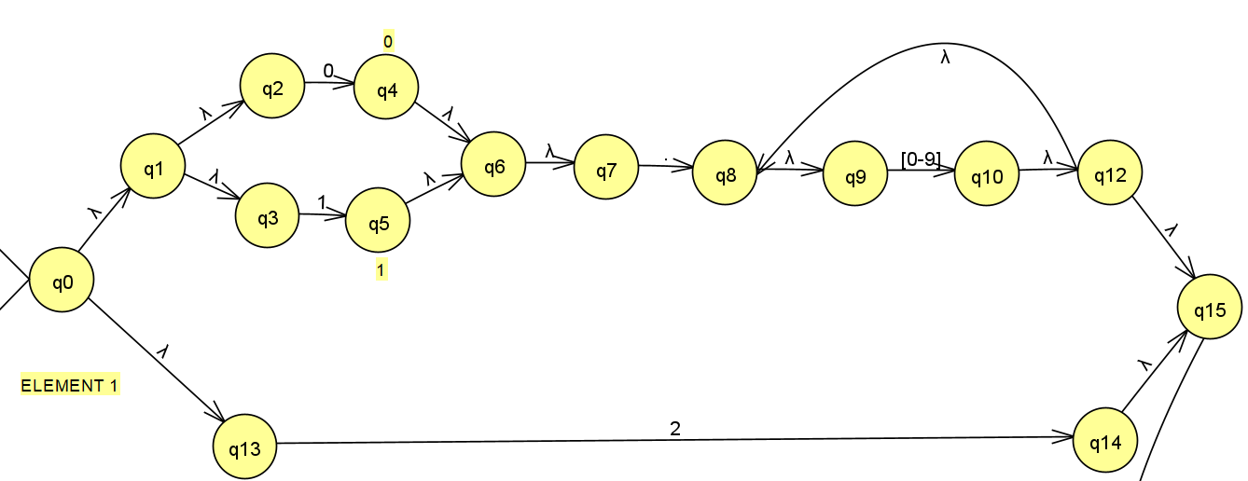

SECOND ELEMENT ε-NFA:
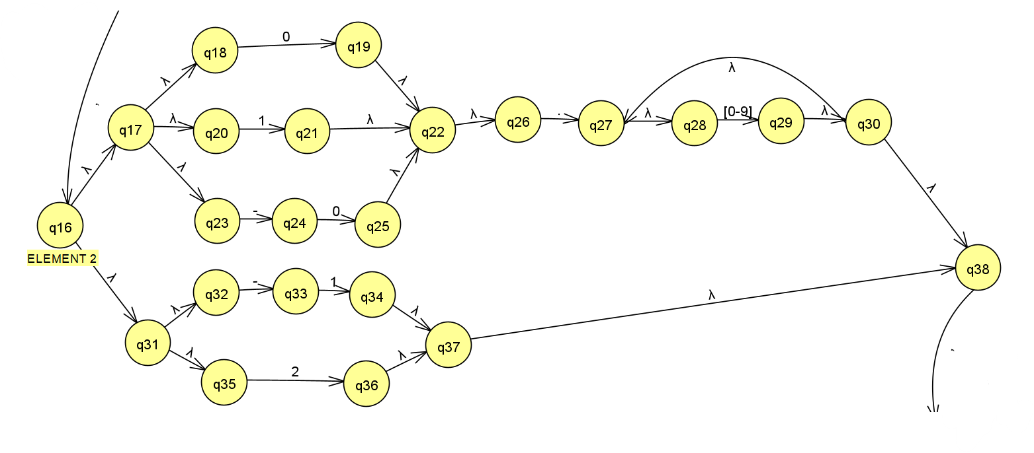

THIRD ELEMENT ε-NFA:
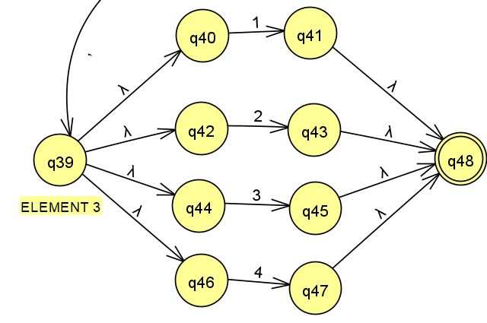

COMPLETE ε-NFA:

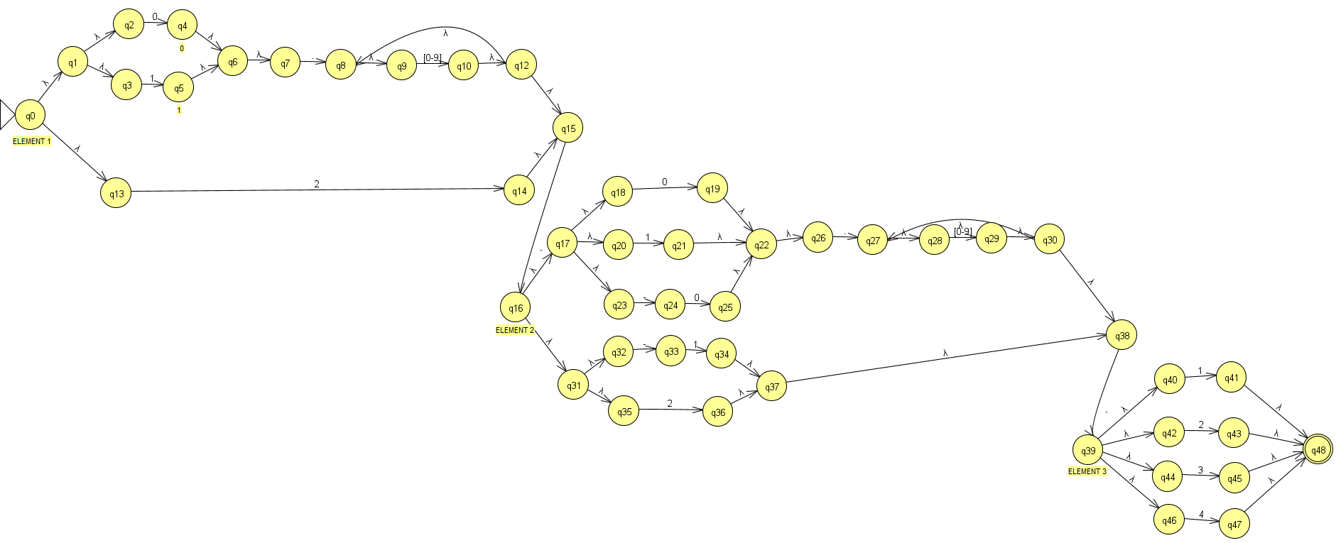

Task 3: Get the minimum DFA equivalent to the designed ℇ-NFA

First we copy the ε-NFA in the table:
Note: All white spaces are Ø states
 | 0 | 1 | 2 | 3 | 4 | 5 | 6 | 7 | 8 | 9 | , | . | - | e
>Q0 |  |  |  |  |  |  |  |  |  |  |  |  |  | Q1,q13
Q1 |  |  |  |  |  |  |  |  |  |  |  |  |  | Q2,q3
Q2 | Q4
Q3 |  | Q5
Q4 |  |  |  |  |  |  |  |  |  |  |  |  |  | Q6
Q5 |  |  |  |  |  |  |  |  |  |  |  |  |  | Q6
Q6 |  |  |  |  |  |  |  |  |  |  |  |  |  | Q7
Q7 |  |  |  |  |  |  |  |  |  |  |  | Q8
Q8 |  |  |  |  |  |  |  |  |  |  |  |  |  | Q9
Q9 | Q10 | Q10 | Q10 | Q10 | Q10 | Q10 | Q10 | Q10 | Q10 | Q10
Q10 |  |  |  |  |  |  |  |  |  |  |  |  |  | Q12
Q12 |  |  |  |  |  |  |  |  |  |  |  |  |  | Q8,q15
Q13 |  |  | Q14
Q14 |  |  |  |  |  |  |  |  |  |  |  |  |  | Q15
Q15 |  |  |  |  |  |  |  |  |  |  | Q16
Q16 |  |  |  |  |  |  |  |  |  |  |  |  |  | Q17,q31
Q17 |  |  |  |  |  |  |  |  |  |  |  |  |  | Q18  q20,q23
Q18 | Q19
Q19 |  |  |  |  |  |  |  |  |  |  |  |  |  | Q22
Q20 |  | Q21
Q21 |  |  |  |  |  |  |  |  |  |  |  |  |  | Q22
Q22 |  |  |  |  |  |  |  |  |  |  |  |  |  | Q26
Q23 |  |  |  |  |  |  |  |  |  |  |  |  | Q24
Q24 | Q25
Q25 |  |  |  |  |  |  |  |  |  |  |  |  |  | Q22
Q26 |  |  |  |  |  |  |  |  |  |  |  | Q27
Q27 |  |  |  |  |  |  |  |  |  |  |  |  |  | Q28
Q28 | Q29 | Q29 | Q29 | Q29 | Q29 | Q29 | Q29 | Q29 | Q29 | Q29
Q29 |  |  |  |  |  |  |  |  |  |  |  |  |  | Q30
Q30 |  |  |  |  |  |  |  |  |  |  |  |  |  | Q38,q27
Q31 |  |  |  |  |  |  |  |  |  |  |  |  |  | Q32,q35
Q32 |  |  |  |  |  |  |  |  |  |  |  |  | Q33
Q33 |  | Q34
Q34 |  |  |  |  |  |  |  |  |  |  |  |  |  | Q37
Q35 |  |  | Q36
Q36 |  |  |  |  |  |  |  |  |  |  |  |  |  | Q37
Q37 |  |  |  |  |  |  |  |  |  |  |  |  |  | Q38
Q38 |  |  |  |  |  |  |  |  |  |  | Q39
Q39 |  |  |  |  |  |  |  |  |  |  |  |  |  | Q40,q42  Q44,q46
Q40 |  | Q41
Q41 |  |  |  |  |  |  |  |  |  |  |  |  |  | Q48
Q42 |  |  | Q43
Q43 |  |  |  |  |  |  |  |  |  |  |  |  |  | Q48
Q44 |  |  |  | Q45
Q45 |  |  |  |  |  |  |  |  |  |  |  |  |  | Q48
Q46 |  |  |  |  | Q47
Q47 |  |  |  |  |  |  |  |  |  |  |  |  |  | Q48
*Q48

Second, we compute all CL(Q)

>Q0 | Q0,Q1,q2,q3,q13
CL(Q1) | Q1,q2,q3
CL(Q2) | Q2
CL(Q3) | Q3
CL(Q4) | Q4,q6,q7
CL(Q5) | Q5,q6,q7
CL(Q6) | Q6,q7
CL(Q7) | Q7
CL(Q8) | Q8,q9
CL(Q9) | Q9
CL(Q10) | Q10,q12,q8,q9,q15
CL(Q12) | Q12,q8,q9,q15
CL(Q13) | Q13
CL(Q14) | Q14,q15
CL(Q15) | Q15
CL(Q16) | Q16,q17,q18,q20,q23,q31,q32,q35
CL(Q17) | Q17,q18,q20,q23
CL(Q18) | Q18
CL(Q19) | Q19,q22,q26
CL(Q20) | Q20
CL(Q21) | Q21,q22,q26
CL(Q22) | Q22,q26
CL(Q23) | Q23
CL(Q24) | Q24
CL(Q25) | Q25,q22,q26
CL(Q26) | Q26
CL(Q27) | Q27,q28
CL(Q28) | Q28
CL(Q29) | Q29,q30,q38,q27,q28
CL(Q30) | Q30,q38,q27,q28
CL(Q31) | Q31,q32,q35
CL(Q32) | Q32
CL(Q33) | Q33
CL(Q34) | Q34,q37,q38,
CL(Q35) | Q35
CL(Q36) | Q36,q37,q38
CL(Q37) | Q37,q38
CL(Q38) | Q38
CL(Q39) | Q39,q40,q42,q44,q46
CL(Q40) | Q40
*CL(Q41) | Q41,q48
CL(Q42) | Q42
*CL(Q43) | Q43,q48
CL(Q44) | Q44
*CL(Q45) | Q45,q48
CL(Q46) | Q46
*CL(Q47) | Q47,q48
*CL(Q48) | Q48

Then, calculate δ_{N}(q, a) ( δ_{N}(q, a) is the union over all p ∈ S of δ_{E}(p, a) is the union over all p ∈ S of δ_{E}(p, a))

 | 0 | 1 | 2 | 3 | 4 | 5 | 6 | 7 | 8 | 9 | , | . | -
>Q0 | Q4 | Q5 | Q14
Q1 | Q4 | Q5
Q2 | Q4
Q3 |  | Q5
Q4 |  |  |  |  |  |  |  |  |  |  |  | Q8
Q5 |  |  |  |  |  |  |  |  |  |  |  | Q8
Q6 |  |  |  |  |  |  |  |  |  |  |  | Q8
Q7 |  |  |  |  |  |  |  |  |  |  |  | Q8
Q8 | Q10 | Q10 | Q10 | Q10 | Q10 | Q10 | Q10 | Q10 | Q10 | Q10
Q9 | Q10 | Q10 | Q10 | Q10 | Q10 | Q10 | Q10 | Q10 | Q10 | Q10
Q10 | Q10 | Q10 | Q10 | Q10 | Q10 | Q10 | Q10 | Q10 | Q10 | Q10 | Q16
Q12 | Q10 | Q10 | Q10 | Q10 | Q10 | Q10 | Q10 | Q10 | Q10 | Q10 | Q16
Q13 |  |  | Q14
Q14 |  |  |  |  |  |  |  |  |  |  | Q16
Q15 |  |  |  |  |  |  |  |  |  |  | Q16
Q16 | Q19 | Q21 | Q36 |  |  |  |  |  |  |  |  |  | Q24,Q33
Q17 | Q19 | Q21 |  |  |  |  |  |  |  |  |  |  | Q24
Q18 | Q19
Q19 |  |  |  |  |  |  |  |  |  |  |  | Q27
Q20 |  | Q21
Q21 |  |  |  |  |  |  |  |  |  |  |  | Q27
Q22 |  |  |  |  |  |  |  |  |  |  |  | Q27
Q23 |  |  |  |  |  |  |  |  |  |  |  |  | Q24
Q24 | Q25
Q25 |  |  |  |  |  |  |  |  |  |  |  | Q27
Q26 |  |  |  |  |  |  |  |  |  |  |  | Q27
Q27 | Q29 | Q29 | Q29 | Q29 | Q29 | Q29 | Q29 | Q29 | Q29 | Q29
Q28 | Q29 | Q29 | Q29 | Q29 | Q29 | Q29 | Q29 | Q29 | Q29 | Q29
Q29 | Q29 | Q29 | Q29 | Q29 | Q29 | Q29 | Q29 | Q29 | Q29 | Q29 | Q39
Q30 | Q29 | Q29 | Q29 | Q29 | Q29 | Q29 | Q29 | Q29 | Q29 | Q29 | Q39
Q31 |  |  | Q36 |  |  |  |  |  |  |  |  |  | Q33
Q32 |  |  |  |  |  |  |  |  |  |  |  |  | Q33
Q33 |  | Q34
Q34 |  |  |  |  |  |  |  |  |  |  | Q39
Q35 |  |  | Q36
Q36 |  |  |  |  |  |  |  |  |  |  | Q39
Q37 |  |  |  |  |  |  |  |  |  |  | Q39
Q38 |  |  |  |  |  |  |  |  |  |  | Q39
Q39 |  | Q41 | Q43 | Q45 | Q47
Q40 |  | Q41
*Q41
Q42 |  |  | Q43
*Q43
Q44 |  |  |  | Q45
*Q45
Q46 |  |  |  |  | Q47
*Q47
*Q48

Note: All white spaces are Ø states

Once we obtain the NFA table, let´s obtain the DFA table transition:
Note: All white spaces(Ø) are replace with a dead state called ?

 | 0 | 1 | 2 | 3 | 4 | 5 | 6 | 7 | 8 | 9 | , | . | -
>Q0 | Q4 | Q5 | Q14 | ? | ? | ? | ? | ? | ? | ? | ? | ? | ?
Q4 | ? | ? | ? | ? | ? | ? | ? | ? | ? | ? | ? | Q8 | ?
Q5 | ? | ? | ? | ? | ? | ? | ? | ? | ? | ? | ? | Q8 | ?
Q14 | ? | ? | ? | ? | ? | ? | ? | ? | ? | ? | Q16 | ? | ?
Q8 | Q10 | Q10 | Q10 | Q10 | Q10 | Q10 | Q10 | Q10 | Q10 | Q10 | ? | ? | ?
Q16 | Q19 | Q21 | Q36 | ? | ? | ? | ? | ? | ? | ? | ? | ? | Q24,Q33
Q10 | Q10 | Q10 | Q10 | Q10 | Q10 | Q10 | Q10 | Q10 | Q10 | Q10 | Q16 | ? | ?
Q19 | ? | ? | ? | ? | ? | ? | ? | ? | ? | ? | ? | Q27 | ?
Q21 | ? | ? | ? | ? | ? | ? | ? | ? | ? | ? | ? | Q27 | ?
Q36 | ? | ? | ? | ? | ? | ? | ? | ? | ? | ? | Q39 | ? | ?
Q24_Q33 | Q25 | Q34 | ? | ? | ? | ? | ? | ? | ? | ? | ? | ? | ?
Q27 | Q29 | Q29 | Q29 | Q29 | Q29 | Q29 | Q29 | Q29 | Q29 | Q29 | ? | ? | ?
Q39 | ? | Q41 | Q43 | Q45 | Q47 | ? | ? | ? | ? | ? | ? | ? | ?
Q25 | ? | ? | ? | ? | ? | ? | ? | ? | ? | ? | ? | Q27 | ?
Q34 | ? | ? | ? | ? | ? | ? | ? | ? | ? | ? | Q39 | ? | ?
Q29 | Q29 | Q29 | Q29 | Q29 | Q29 | Q29 | Q29 | Q29 | Q29 | Q29 | Q39 | ? | ?
*Q41 | ? | ? | ? | ? | ? | ? | ? | ? | ? | ? | ? | ? | ?
*Q43 | ? | ? | ? | ? | ? | ? | ? | ? | ? | ? | ? | ? | ?
*Q45 | ? | ? | ? | ? | ? | ? | ? | ? | ? | ? | ? | ? | ?
*Q47 | ? | ? | ? | ? | ? | ? | ? | ? | ? | ? | ? | ? | ?
? | ? | ? | ? | ? | ? | ? | ? | ? | ? | ? | ? | ? | ?

Now let’s construct the obtained DFA in JFLAP:
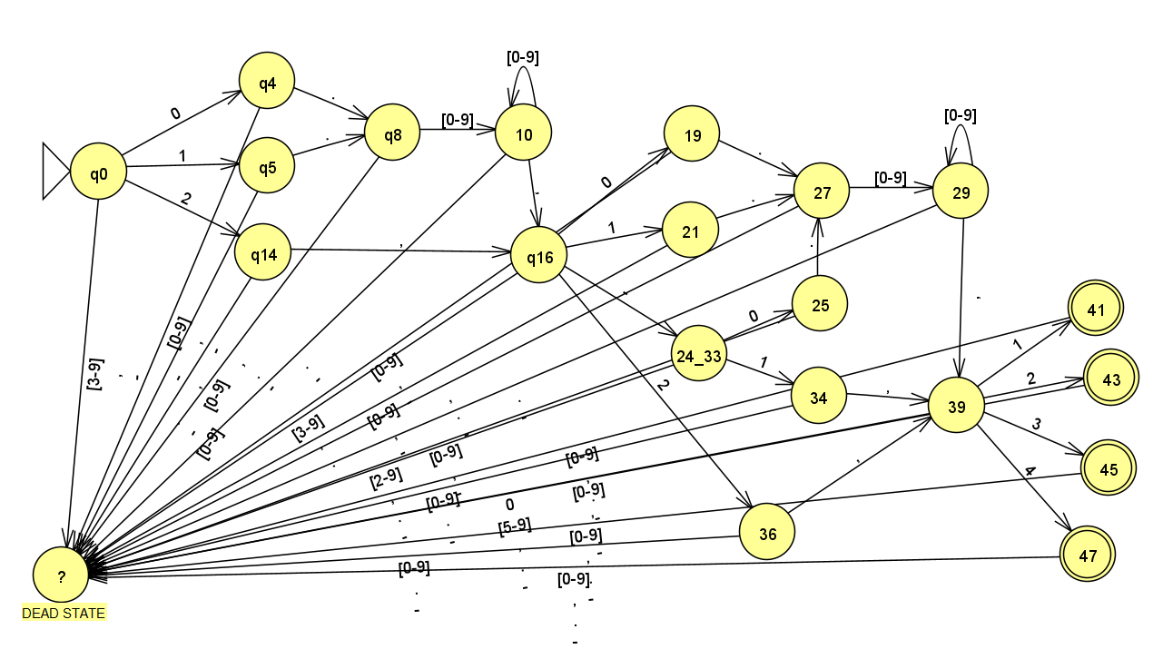
For a better understanding, i will eliminate those transitions to dead states.

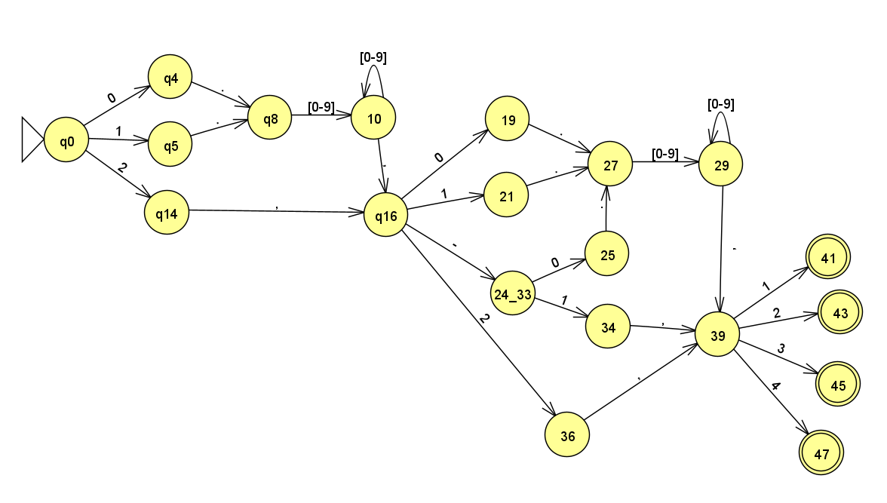

Finally we will minimize the DFA, with the following algorithm:

1. Build a table with all pairs of states
2. Mark all pairs of distinguishable states
1. Mark those pairs with
• One final state
• One non-final state
2. Mark those pairs [q, r] if
• ∃a / [δ(q,a), δ(r,a)] is marked
3. Go to 2 until no more marks are possible
3. All unmarked pairs represent equivalent states – Remove equivalent states

 | ? | Q47 | Q45 | Q43 | Q41 | 29 | 34 | 25 | 39 | 27 | 24_33 | 36 | 21 | 19 | 10 | 16 | 8 | 14 | 5 | 4
>Q0 | X | X | X | X | x | X | X | X | X | X | X | X | X | X | X | X | X | X | X | X
Q4 | X | X | X | X | X | X | X | X | X | X | X | X | X | X | X | X | X | X |  | -
Q5 | X | X | X | X | X | X | X | X | X | X | X | X | X | X | X | X | X | X | -
Q14 | X | X | X | X | X | X | X | X | X | X | X | X | X | X | X | X | X | -
Q8 | X | X | X | X | X | X | X | X | X | X | X | X | X | X | X | X | -
Q16 | X | X | X | X | X | X | X | X | X | X | X | X | X | X | X | -
Q10 | X | X | X | X | X | X | X | X | X | X | X | X | X | X | -
Q19 | X | X | X | X | X | X | X |  | X | X | X | X |  | -
Q21 | X | X | X | X | X | X | X |  | X | X | X | X | -
Q36 | X | X | X | X | X | X |  | X | X | X | X | -
Q24_Q33 | X | X | X | X | X | X | X | X | X | X | -
Q27 | X | X | X | X | X | X | X | X | X | -
Q39 | X | X | X | X | X | X | X | X | -
Q25 | X | X | X | X | X | X | X | -
Q34 | X | X | X | X | X | X | -
Q29 | X | X | X | X | x | -
*Q41 | X |  |  |  | -
*Q43 | X |  |  | -
*Q45 | X |  | -
*Q47 | X | -

Equivalent States:
Q4 and Q5
Q19, Q25 and Q21
Q36 and Q34
Q41, Q47, Q45 and Q43

All aparitions of Q5 is called Q4
All aparitions of Q25 and Q21 is called Q9
All aparitions of Q36 is called Q34
All aparitions of Q47 and Q45 is called Q41

Minimized DFA:
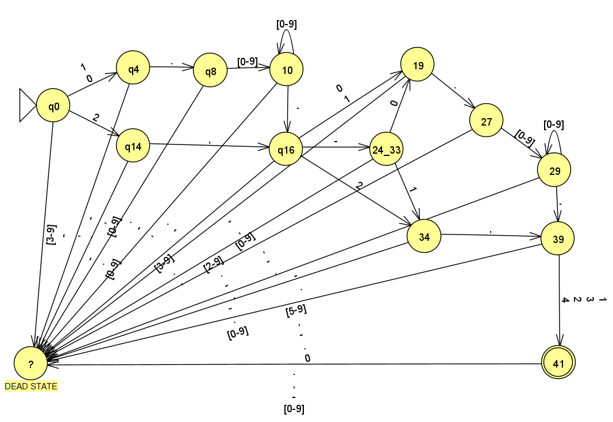

Also the company has detected that some steels that include number 25 in their decimal numbers can cause some danger so they need to identify these entries.
Task 4: Design a minimum DFA that accepts database entries, correct or not, where the decimal part of the element 1 has the number 25 in it.

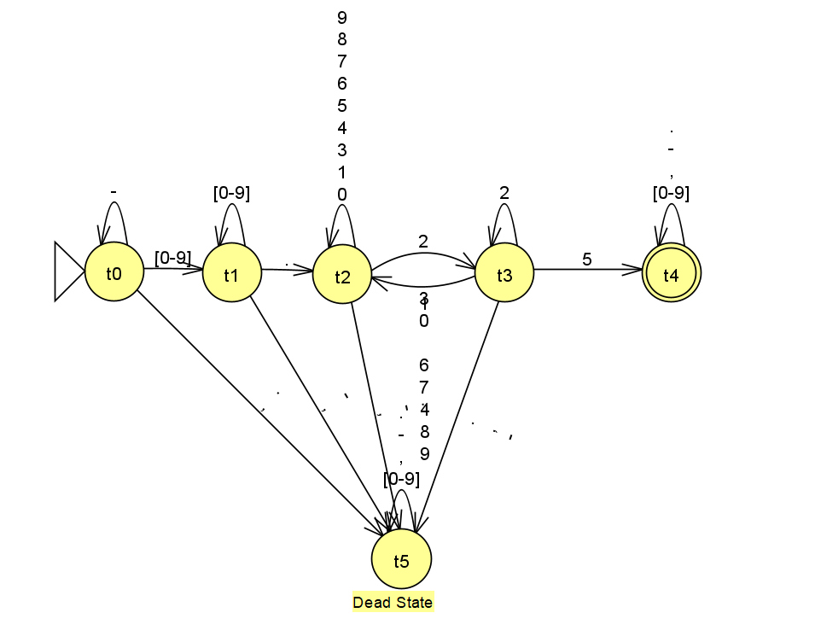

Task 5: Combine de DFAs designed in tasks 3 and 4 with the product automaton method to find a DFA that accepts only correct entries in which the element1 has number 25 in its decimals.

For the automata product, I will use Excel to be able to combine them more easily.

Once the table is obtained, I will start with the initial state, in our case Q0t0, since Q0 is the initial state of our first automaton and t0 is the initial state of our second automaton.
Well, in order to minimize the automated product as much as possible, I will only put those states that I find along the way (starting by Q0t0, our initial state). To minimize it even more, I will take those states that contains the dead state t5 or ? as a single dead state ?
For example, Q0t0 has transitions to Q4, Q14 and ?, So we will put those transitions and so on until no new state is found, just like the algortithm that converts NFA to DFA.

 | 0 | 1 | 2 | 3 | 4 | 5 | 6 | 7 | 8 | 9 | , | . | -
>Q0t0 | Q4t1 | Q4t1 | Q14t1 | ?t1 | ?t1 | ?t1 | ?t1 | ?t1 | ?t1 | ?t1 | ?t5 | ?t5 | ?t0
Qot1 | Q4t1 | Q4t1 | Q14t1 | ?t1 | ?t1 | ?t1 | ?t1 | ?t1 | ?t1 | ?t1 | ?t5 | ?t2 | ?t5
Qot2 | Q4t2 | Q4t2 | Q14t3 | ?t2 | ?t2 | ?t2 | ?t2 | ?t2 | ?t2 | ?t2 | ?t5 | ?t5 | ?t5
Qot3 | Q4t2 | Q4t2 | Q14t3 | ?t2 | ?t2 | ?t4 | ?t2 | ?t2 | ?t2 | ?t2 | ?t5 | ?t5 | ?t5
Qot4 | Q4t4 | Q4t4 | Q14t4 | ?t4 | ?t4 | ?t4 | ?t4 | ?t4 | ?t4 | ?t4 | ?t4 | ?t4 | ?t4
Qot5 | Q4t5 | Q4t5 | Q14t5 | ?t5 | ?t5 | ?t5 | ?t5 | ?t5 | ?t5 | ?t5 | ?t5 | ?t5 | ?t5
Q4t0 | ?t1 | ?t1 | ?t1 | ?t1 | ?t1 | ?t1 | ?t1 | ?t1 | ?t1 | ?t1 | ?t5 | Q8t5 | ?t0
Q4t1 | ?t1 | ?t1 | ?t1 | ?t1 | ?t1 | ?t1 | ?t1 | ?t1 | ?t1 | ?t1 | ?t5 | Q8t2 | ?t5
Q4t2 | ?t2 | ?t2 | ?t3 | ?t2 | ?t2 | ?t2 | ?t2 | ?t2 | ?t2 | ?t2 | ?t5 | Q8t5 | ?t5
Q4t3 | ?t2 | ?t2 | ?t3 | ?t2 | ?t2 | ?t4 | ?t2 | ?t2 | ?t2 | ?t2 | ?t5 | Q8t5 | ?t5
Q4t4 | ?t4 | ?t4 | ?t4 | ?t4 | ?t4 | ?t4 | ?t4 | ?t4 | ?t4 | ?t4 | ?t4 | Q8t4 | ?t4
Q4t5 | ?t5 | ?t5 | ?t5 | ?t5 | ?t5 | ?t5 | ?t5 | ?t5 | ?t5 | ?t5 | ?t5 | Q8t5 | ?t5
Q14t0 | ?t1 | ?t1 | ?t1 | ?t1 | ?t1 | ?t1 | ?t1 | ?t1 | ?t1 | ?t1 | Q16t5 | ?t5 | ?t0
Q14t1 | ?t1 | ?t1 | ?t1 | ?t1 | ?t1 | ?t1 | ?t1 | ?t1 | ?t1 | ?t1 | Q16t5 | ?t2 | ?t5
Q14t2 | ?t2 | ?t2 | ?t3 | ?t2 | ?t2 | ?t2 | ?t2 | ?t2 | ?t2 | ?t2 | Q16t5 | ?t5 | ?t5
Q14t3 | ?t2 | ?t2 | ?t3 | ?t2 | ?t2 | ?t4 | ?t2 | ?t2 | ?t2 | ?t2 | Q16t5 | ?t5 | ?t5
Q14t4 | ?t4 | ?t4 | ?t4 | ?t4 | ?t4 | ?t4 | ?t4 | ?t4 | ?t4 | ?t4 | Q16t4 | ?t4 | ?t4
Q14t5 | ?t5 | ?t5 | ?t5 | ?t5 | ?t5 | ?t5 | ?t5 | ?t5 | ?t5 | ?t5 | Q16t5 | ?t5 | ?t5
Q8t0 | Q10t1 | Q10t1 | Q10t1 | Q10t1 | Q10t1 | Q10t1 | Q10t1 | Q10t1 | Q10t1 | Q10t1 | ?t5 | ?t5 | ?t0
Q8t1 | Q10t1 | Q10t1 | Q10t1 | Q10t1 | Q10t1 | Q10t1 | Q10t1 | Q10t1 | Q10t1 | Q10t1 | ?t5 | ?t2 | ?t5
Q8t2 | Q10t2 | Q10t2 | Q10t3 | Q10t2 | Q10t2 | Q10t2 | Q10t2 | Q10t2 | Q10t2 | Q10t2 | ?t5 | ?t5 | ?t5
Q8t3 | Q10t2 | Q10t2 | Q10t3 | Q10t2 | Q10t2 | Q10t4 | Q10t2 | Q10t2 | Q10t2 | Q10t2 | ?t5 | ?t5 | ?t5
Q8t4 | Q10t4 | Q10t4 | Q10t4 | Q10t4 | Q10t4 | Q10t4 | Q10t4 | Q10t4 | Q10t4 | Q10t4 | ?t4 | ?t4 | ?t4
Q8t5 | Q10t5 | Q10t5 | Q10t5 | Q10t5 | Q10t5 | Q10t5 | Q10t5 | Q10t5 | Q10t5 | Q10t5 | ?t5 | ?t5 | ?t5
Q16t0 | Q19t1 | Q19t1 | Q34t1 | ?t1 | ?t1 | ?t1 | ?t1 | ?t1 | ?t1 | ?t1 | ?t5 | ?t5 | Q24_Q33t0
Q16t1 | Q19t1 | Q19t1 | Q34t1 | ?t1 | ?t1 | ?t1 | ?t1 | ?t1 | ?t1 | ?t1 | ?t5 | ?t2 | Q24_Q33t5
Q16t2 | Q19t2 | Q19t2 | Q34t3 | ?t2 | ?t2 | ?t2 | ?t2 | ?t2 | ?t2 | ?t2 | ?t5 | ?t5 | Q24_Q33t5
Q16t3 | Q19t2 | Q19t2 | Q34t3 | ?t2 | ?t2 | ?t4 | ?t2 | ?t2 | ?t2 | ?t2 | ?t5 | ?t5 | Q24_Q33t5
Q16t4 | Q19t4 | Q19t4 | Q34t4 | ?t4 | ?t4 | ?t4 | ?t4 | ?t4 | ?t4 | ?t4 | ?t4 | ?t4 | Q24_Q33t4
Q16t5 | Q19t5 | Q19t5 | Q34t5 | ?t5 | ?t5 | ?t5 | ?t5 | ?t5 | ?t5 | ?t5 | ?t5 | ?t5 | Q24_Q33t5
Q10t0 | Q10t1 | Q10t1 | Q10t1 | Q10t1 | Q10t1 | Q10t1 | Q10t1 | Q10t1 | Q10t1 | Q10t1 | Q16t5 | ?t5 | ?t0
Q10t1 | Q10t1 | Q10t1 | Q10t1 | Q10t1 | Q10t1 | Q10t1 | Q10t1 | Q10t1 | Q10t1 | Q10t1 | Q16t5 | ?t2 | ?t5
Q10t2 | Q10t2 | Q10t2 | Q10t3 | Q10t2 | Q10t2 | Q10t2 | Q10t2 | Q10t2 | Q10t2 | Q10t2 | Q16t5 | ?t5 | ?t5
Q10t3 | Q10t2 | Q10t2 | Q10t3 | Q10t2 | Q10t2 | Q10t4 | Q10t2 | Q10t2 | Q10t2 | Q10t2 | Q16t5 | ?t5 | ?t5
Q10t4 | Q10t4 | Q10t4 | Q10t4 | Q10t4 | Q10t4 | Q10t4 | Q10t4 | Q10t4 | Q10t4 | Q10t4 | Q16t4 | ?t4 | ?t4
Q10t5 | Q10t5 | Q10t5 | Q10t5 | Q10t5 | Q10t5 | Q10t5 | Q10t5 | Q10t5 | Q10t5 | Q10t5 | Q16t5 | ?t5 | ?t5
Q19t0 | ?t1 | ?t1 | ?t1 | ?t1 | ?t1 | ?t1 | ?t1 | ?t1 | ?t1 | ?t1 | ?t5 | Q27t5 | ?t0
Q19t1 | ?t1 | ?t1 | ?t1 | ?t1 | ?t1 | ?t1 | ?t1 | ?t1 | ?t1 | ?t1 | ?t5 | Q27t2 | ?t5
Q19t2 | ?t2 | ?t2 | ?t3 | ?t2 | ?t2 | ?t2 | ?t2 | ?t2 | ?t2 | ?t2 | ?t5 | Q27t5 | ?t5
Q19t3 | ?t2 | ?t2 | ?t3 | ?t2 | ?t2 | ?t4 | ?t2 | ?t2 | ?t2 | ?t2 | ?t5 | Q27t5 | ?t5
Q19t4 | ?t4 | ?t4 | ?t4 | ?t4 | ?t4 | ?t4 | ?t4 | ?t4 | ?t4 | ?t4 | ?t4 | Q27t4 | ?t4
Q19t5 | ?t5 | ?t5 | ?t5 | ?t5 | ?t5 | ?t5 | ?t5 | ?t5 | ?t5 | ?t5 | ?t5 | Q27t5 | ?t5
Q24_33t0 | Q19t1 | Q34t1 | ?t1 | ?t1 | ?t1 | ?t1 | ?t1 | ?t1 | ?t1 | ?t1 | ?t5 | ?t5 | ?t0
Q24_33t1 | Q19t1 | Q34t1 | ?t1 | ?t1 | ?t1 | ?t1 | ?t1 | ?t1 | ?t1 | ?t1 | ?t5 | ?t2 | ?t5
Q24_33t2 | Q19t2 | Q34t2 | ?t3 | ?t2 | ?t2 | ?t2 | ?t2 | ?t2 | ?t2 | ?t2 | ?t5 | ?t5 | ?t5
Q24_33t3 | Q19t2 | Q34t2 | ?t3 | ?t2 | ?t2 | ?t4 | ?t2 | ?t2 | ?t2 | ?t2 | ?t5 | ?t5 | ?t5
Q24_33t4 | Q19t4 | Q34t4 | ?t4 | ?t4 | ?t4 | ?t4 | ?t4 | ?t4 | ?t4 | ?t4 | ?t4 | ?t4 | ?t4
Q24_33t5 | Q19t5 | Q34t5 | ?t5 | ?t5 | ?t5 | ?t5 | ?t5 | ?t5 | ?t5 | ?t5 | ?t5 | ?t5 | ?t5
Q27t0 | Q29t1 | Q29t1 | Q29t1 | Q29t1 | Q29t1 | Q29t1 | Q29t1 | Q29t1 | Q29t1 | Q29t1 | ?t5 | ?t5 | ?t0
Q27t1 | Q29t1 | Q29t1 | Q29t1 | Q29t1 | Q29t1 | Q29t1 | Q29t1 | Q29t1 | Q29t1 | Q29t1 | ?t5 | ?t2 | ?t5
Q27t2 | Q29t2 | Q29t2 | Q29t3 | Q29t2 | Q29t2 | Q29t2 | Q29t2 | Q29t2 | Q29t2 | Q29t2 | ?t5 | ?t5 | ?t5
Q27t3 | Q29t2 | Q29t2 | Q29t3 | Q29t2 | Q29t2 | Q29t4 | Q29t2 | Q29t2 | Q29t2 | Q29t2 | ?t5 | ?t5 | ?t5
Q27t4 | Q29t4 | Q29t4 | Q29t4 | Q29t4 | Q29t4 | Q29t4 | Q29t4 | Q29t4 | Q29t4 | Q29t4 | ?t4 | ?t4 | ?t4
Q27t5 | Q29t5 | Q29t5 | Q29t5 | Q29t5 | Q29t5 | Q29t5 | Q29t5 | Q29t5 | Q29t5 | Q29t5 | ?t5 | ?t5 | ?t5
Q39t0 | ?t1 | Q41t1 | Q41t1 | Q41t1 | Q41t1 | ?t1 | ?t1 | ?t1 | ?t1 | ?t1 | ?t5 | ?t5 | ?t0
Q39t1 | ?t1 | Q41t1 | Q41t1 | Q41t1 | Q41t1 | ?t1 | ?t1 | ?t1 | ?t1 | ?t1 | ?t5 | ?t2 | ?t5
Q39t2 | ?t2 | Q41t2 | Q41t3 | Q41t2 | Q41t2 | ?t2 | ?t2 | ?t2 | ?t2 | ?t2 | ?t5 | ?t5 | ?t5
Q39t3 | ?t2 | Q41t2 | Q41t3 | Q41t2 | Q41t2 | ?t4 | ?t2 | ?t2 | ?t2 | ?t2 | ?t5 | ?t5 | ?t5
Q39t4 | ?t4 | Q41t4 | Q41t4 | Q41t4 | Q41t4 | ?t4 | ?t4 | ?t4 | ?t4 | ?t4 | ?t4 | ?t4 | ?t4
Q39t5 | ?t5 | Q41t5 | Q41t5 | Q41t5 | Q41t5 | ?t5 | ?t5 | ?t5 | ?t5 | ?t5 | ?t5 | ?t5 | ?t5
Q34t0 | ?t1 | ?t1 | ?t1 | ?t1 | ?t1 | ?t1 | ?t1 | ?t1 | ?t1 | ?t1 | Q39t5 | ?t5 | ?t0
Q34t1 | ?t1 | ?t1 | ?t1 | ?t1 | ?t1 | ?t1 | ?t1 | ?t1 | ?t1 | ?t1 | Q39t5 | ?t2 | ?t5
Q34t2 | ?t2 | ?t2 | ?t3 | ?t2 | ?t2 | ?t2 | ?t2 | ?t2 | ?t2 | ?t2 | Q39t5 | ?t5 | ?t5
Q34t3 | ?t2 | ?t2 | ?t3 | ?t2 | ?t2 | ?t4 | ?t2 | ?t2 | ?t2 | ?t2 | Q39t5 | ?t5 | ?t5
Q34t4 | ?t4 | ?t4 | ?t4 | ?t4 | ?t4 | ?t4 | ?t4 | ?t4 | ?t4 | ?t4 | Q39t4 | ?t4 | ?t4
Q34t5 | ?t5 | ?t5 | ?t5 | ?t5 | ?t5 | ?t5 | ?t5 | ?t5 | ?t5 | ?t5 | Q39t5 | ?t5 | ?t5
Q29t0 | Q29t1 | Q29t1 | Q29t1 | Q29t1 | Q29t1 | Q29t1 | Q29t1 | Q29t1 | Q29t1 | Q29t1 | Q39t5 | ?t5 | ?t0
Q29t1 | Q29t1 | Q29t1 | Q29t1 | Q29t1 | Q29t1 | Q29t1 | Q29t1 | Q29t1 | Q29t1 | Q29t1 | Q39t5 | ?t2 | ?t5
Q29t2 | Q29t2 | Q29t2 | Q29t3 | Q29t2 | Q29t2 | Q29t2 | Q29t2 | Q29t2 | Q29t2 | Q29t2 | Q39t5 | ?t5 | ?t5
Q29t3 | Q29t2 | Q29t2 | Q29t3 | Q29t2 | Q29t2 | Q29t4 | Q29t2 | Q29t2 | Q29t2 | Q29t2 | Q39t5 | ?t5 | ?t5
Q29t4 | Q29t4 | Q29t4 | Q29t4 | Q29t4 | Q29t4 | Q29t4 | Q29t4 | Q29t4 | Q29t4 | Q29t4 | Q39t4 | ?t4 | ?t4
Q29t5 | Q29t5 | Q29t5 | Q29t5 | Q29t5 | Q29t5 | Q29t5 | Q29t5 | Q29t5 | Q29t5 | Q29t5 | Q39t5 | ?t5 | ?t5
Q41t0 | ?t1 | ?t1 | ?t1 | ?t1 | ?t1 | ?t1 | ?t1 | ?t1 | ?t1 | ?t1 | ?t5 | ?t5 | ?t0
Q41t1 | ?t1 | ?t1 | ?t1 | ?t1 | ?t1 | ?t1 | ?t1 | ?t1 | ?t1 | ?t1 | ?t5 | ?t2 | ?t5
Q41t2 | ?t2 | ?t2 | ?t3 | ?t2 | ?t2 | ?t2 | ?t2 | ?t2 | ?t2 | ?t2 | ?t5 | ?t5 | ?t5
Q41t3 | ?t2 | ?t2 | ?t3 | ?t2 | ?t2 | ?t4 | ?t2 | ?t2 | ?t2 | ?t2 | ?t5 | ?t5 | ?t5
*Q41t4 | ?t4 | ?t4 | ?t4 | ?t4 | ?t4 | ?t4 | ?t4 | ?t4 | ?t4 | ?t4 | ?t4 | ?t4 | ?t4
Q41t5 | ?t5 | ?t5 | ?t5 | ?t5 | ?t5 | ?t5 | ?t5 | ?t5 | ?t5 | ?t5 | ?t5 | ?t5 | ?t5
?t0 | ?t1 | ?t1 | ?t1 | ?t1 | ?t1 | ?t1 | ?t1 | ?t1 | ?t1 | ?t1 | ?t5 | ?t5 | ?t0
?t1 | ?t1 | ?t1 | ?t1 | ?t1 | ?t1 | ?t1 | ?t1 | ?t1 | ?t1 | ?t1 | ?t5 | ?t2 | ?t5
?t2 | ?t2 | ?t2 | ?t3 | ?t2 | ?t2 | ?t2 | ?t2 | ?t2 | ?t2 | ?t2 | ?t5 | ?t5 | ?t5
?t3 | ?t2 | ?t2 | ?t3 | ?t2 | ?t2 | ?t4 | ?t2 | ?t2 | ?t2 | ?t2 | ?t5 | ?t5 | ?t5
?t4 | ?t4 | ?t4 | ?t4 | ?t4 | ?t4 | ?t4 | ?t4 | ?t4 | ?t4 | ?t4 | ?t4 | ?t4 | ?t4
?t5 | ?t5 | ?t5 | ?t5 | ?t5 | ?t5 | ?t5 | ?t5 | ?t5 | ?t5 | ?t5 | ?t5 | ?t5 | ?t5

Once the states we are crossing have been obtained, we obtain the following table, which corresponds to the minimized product automata.

 | 0 | 1 | 2 | 3 | 4 | 5 | 6 | 7 | 8 | 9 | , | . | -
>Q0t0 | Q4t1 | Q4t1 | Q14t1 | ? | ? | ? | ? | ? | ? | ? | ? | ? | ?
Q4t1 | ? | ? | ? | ? | ? | ? | ? | ? | ? | ? | ? | Q8t2 | ?
Q14t1 | ? | ? | ? | ? | ? | ? | ? | ? | ? | ? | ? | ? | ?
Q8t2 | Q10t2 | Q10t2 | Q10t3 | Q10t2 | Q10t2 | Q10t2 | Q10t2 | Q10t2 | Q10t2 | Q10t2 | ? | ? | ?
Q10t2 | Q10t2 | Q10t2 | Q10t3 | Q10t2 | Q10t2 | Q10t2 | Q10t2 | Q10t2 | Q10t2 | Q10t2 | ? | ? | ?
Q10t3 | Q10t2 | Q10t2 | Q10t3 | Q10t2 | Q10t2 | Q10t4 | Q10t2 | Q10t2 | Q10t2 | Q10t2 | ? | ? | ?
Q10t4 | Q10t4 | Q10t4 | Q10t4 | Q10t4 | Q10t4 | Q10t4 | Q10t4 | Q10t4 | Q10t4 | Q10t4 | Q16t4 | ? | ?
Q16t4 | Q19t4 | Q19t4 | Q34t4 | ? | ? | ? | ? | ? | ? | ? | ? | ? | Q24_Q33t4
Q24_33t4 | Q19t4 | Q34t4 | ? | ? | ? | ? | ? | ? | ? | ? | ? | ? | ?
Q19t4 | ? | ? | ? | ? | ? | ? | ? | ? | ? | ? | ? | Q27t4 | ?
Q34t4 | ? | ? | ? | ? | ? | ? | ? | ? | ? | ? | Q39t4 | ? | ?
Q27t4 | Q29t4 | Q29t4 | Q29t4 | Q29t4 | Q29t4 | Q29t4 | Q29t4 | Q29t4 | Q29t4 | Q29t4 | ? | ? | ?
Q29t4 | Q29t4 | Q29t4 | Q29t4 | Q29t4 | Q29t4 | Q29t4 | Q29t4 | Q29t4 | Q29t4 | Q29t4 | Q39t4 | ? | ?
Q39t4 | ? | Q41t4 | Q41t4 | Q41t4 | Q41t4 | ? | ? | ? | ? | ? | ? | ? | ?
*Q41t4 | ? | ? | ? | ? | ? | ? | ? | ? | ? | ? | ? | ? | ?
? | ? | ? | ? | ? | ? | ? | ? | ? | ? | ? | ? | ? | ?

Product DFA:
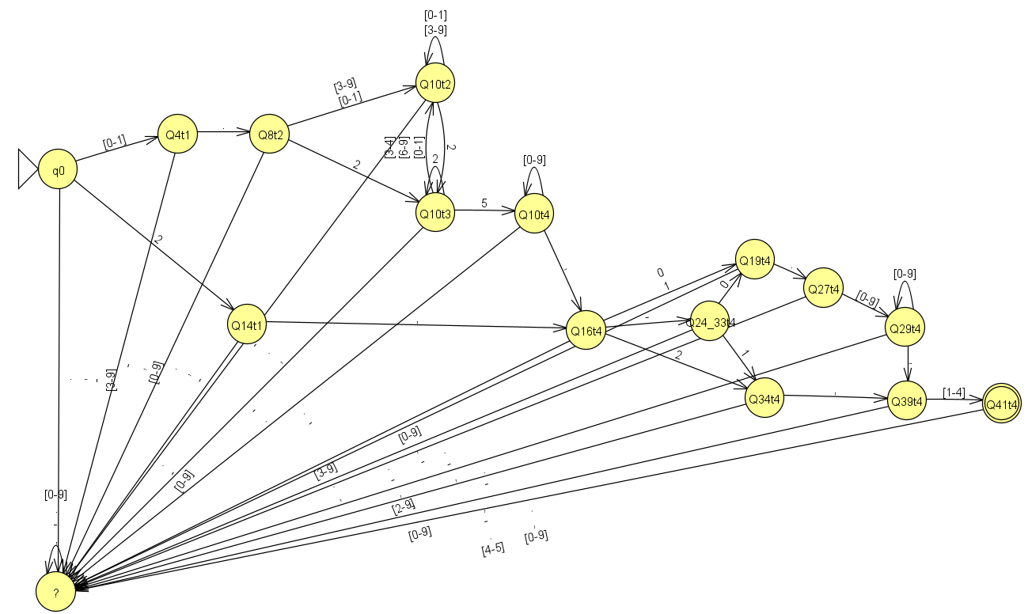

For a better understanding, i will eliminate those transitions to dead states.

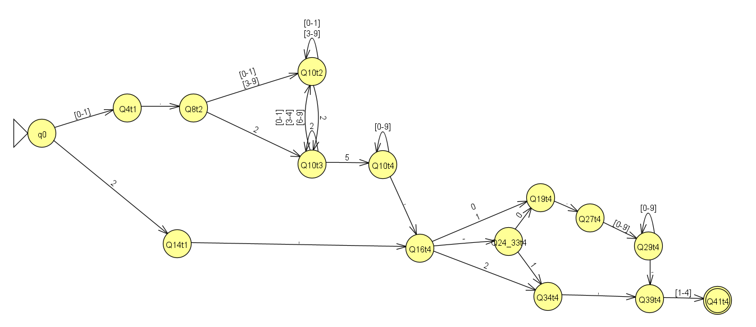

Task 6: Implement in your favorite language the obtained DFA using the table method. The program must read a file with the database and print the correct entries where the element1 has the number 25 in its decimal part.

Note: The states have been renamed, as follows to better code it. The code is written in java language.

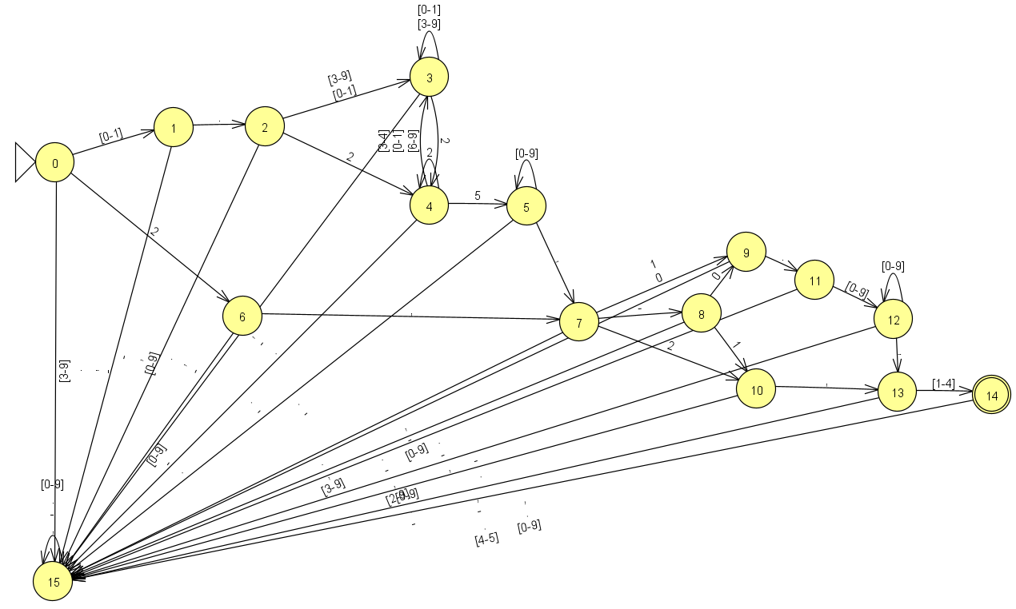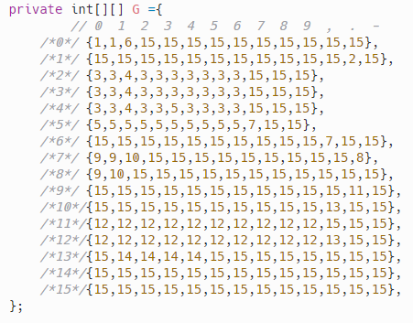

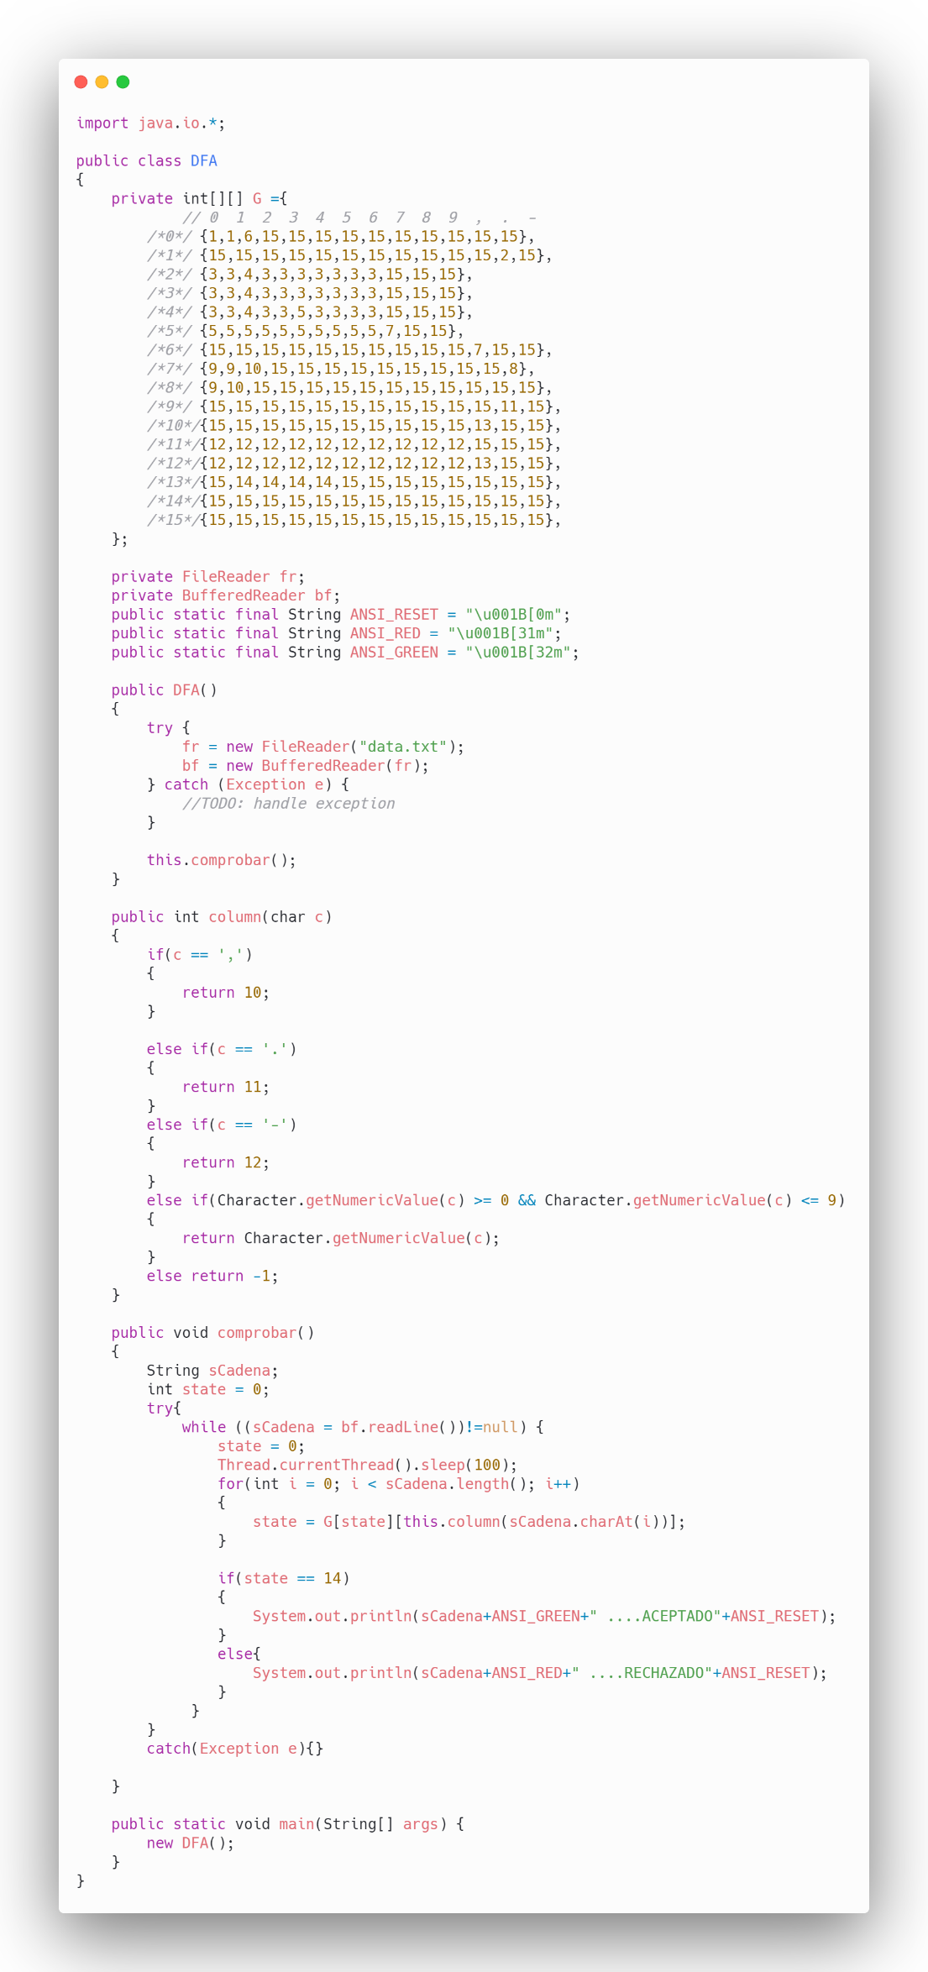
Some test cases:

